**Instruction Sheet**

1) You will be presented with items similar to those in the first task and have to respond in the same way, is the item Natural or Man-made:

Natural

Man-made

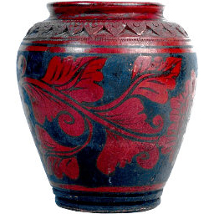

2) After each trial the computer will tell you whether or not you were rewarded for this decision.

**OR**

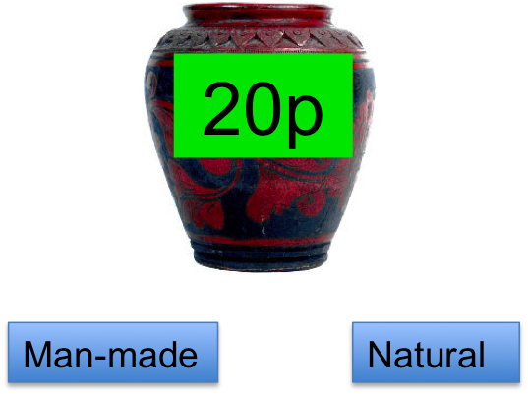

Natural

Man-made



0

3) If there is a possibility of being rewarded, you will only get the reward if you respond very quickly. If you are too slow to respond, the computer will tell you:

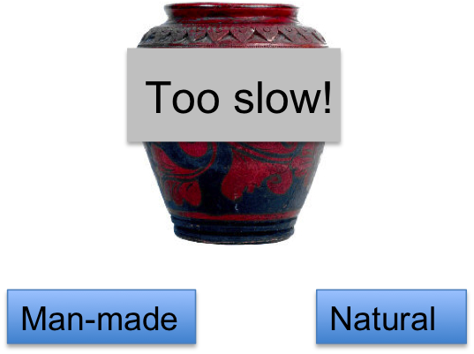

If there is no reward available, you still have to respond within two seconds.

**NOTE:** If your accuracy for deciding if an item is man-made or natural falls too low, you will not be given the money you win on the task

4) After a few trials, you will begin to work out that for one category there is a very high chance of being rewarded, and for another there is a very low chance of being rewarded. By the end of this phase, you should definitely know which of the categories is most likely to get rewarded.

Sometimes, a picture of a room will also be shown onscreen, before the items are presented. These pictures are not relevant to the task at all – they have no relationship to what type of items are likely to come out, or whether you are likely to win money or not. The task that you are doing only relates to the pictures of the natural and man-made items that come onscreen.

**IMPORTANT** Don’t forget that you still have to respond *accurately* even if you think there is no reward available. If your overall accuracy falls below a certain threshold, you will NOT receive the extra money that you win on the task!

**THE MONEY YOU WIN ON THE TASK WILL AFFECT HOW MUCH MONEY YOU TAKE HOME AT THE END OF SESSION 2.**